**Indian Statistical Institute**

**BSDS: 2024-26**

**First Year: Semester – II**

**Economics-II**

**Practical Exercise 6**

1. The following table gives the size distribution of monthly income of 460 individuals collected in a survey.

Table 1: Size Distribution of monthly income of 460 individuals

|  |  |
| --- | --- |
| Income Class  (Rs.) | No. of persons |
| 0 – 500 | 28 |
| 500 – 1000 | 50 |
| 1000 – 1500 | 82 |
| 1500 – 2000 | 100 |
| 2000 – 2500 | 92 |
| 2500 – 3000 | 42 |
| 3000 – 3500 | 30 |
| 3500 – 4000 | 11 |
| 4000 – 4500 | 9 |
| 4500 – 5000 | 7 |
| 5000 – 5500 | 3 |
| 5500 & above | 6 |

Find graphically the appropriate range of income over which Pareto law holds. Also fit the distribution in the appropriate range and perform a χ2 test of goodness of fit.

**Solution to Qn.1:**

|  |  |  |  |  |  |
| --- | --- | --- | --- | --- | --- |
| Income Class  ($x_{i-1}- x_{i}$) | f | Lower boundary  (x) | Cum. Freq. $$\left(≥type\right)$$ $$\left(N_{x}\right)$$ | Ln(x) | Ln( $N_{x})$ |
| 0 – 500 | 28 |  |  |  |  |
| 500 – 1000 | 50 | 500 | 432 | 6.2146 | 6.0684 |
| 1000 – 1500 | 82 | 1000 | 382 | 6.9078 | 5.9454 |
| 1500 – 2000 | 100 | 1500 | 300 | 7.3132 | 5.7038 |
| 2000 – 2500 | 92 | 2000 | 200 | 7.6009 | 5.2983 |
| 2500 – 3000 | 42 | 2500 | 108 | 7.8240 | 4.6821 |
| 3000 – 3500 | 30 | 3000 | 66 | 8.0064 | 4.1897 |
| 3500 – 4000 | 11 | 3500 | 36 | 8.1605 | 3.5835 |
| 4000 – 4500 | 9 | 4000 | 25 | 8.2940 | 3.2189 |
| 4500 – 5000 | 7 | 4500 | 16 | 8.4118 | 2.7726 |
| 5000 – 5500 | 3 | 5000 | 9 | 8.5172 | 2.1972 |
| 5500 & above | 6 | 5500 | 6 | 8.6125 | 1.7918 |

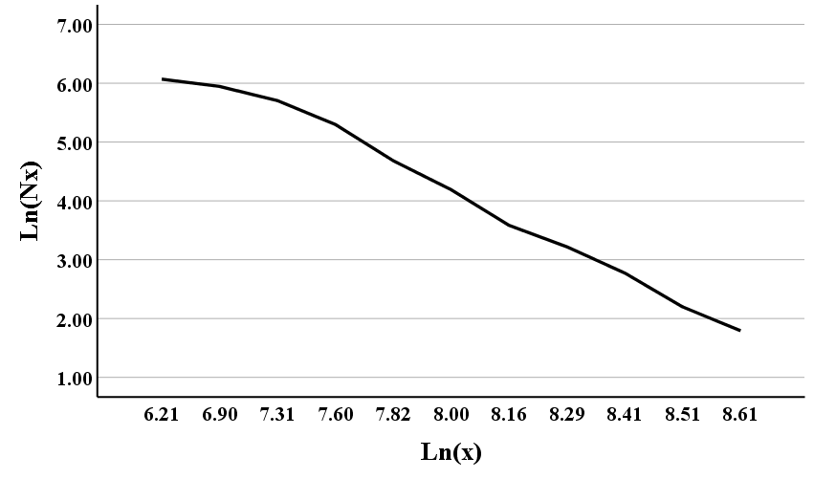

$$Ln(x) ≈ 7.35 ⇒ x = 1556.197 ≈ 1560.$$

$$\frac{2000-1560}{2000-1500}=\frac{N_{0}-200}{300-200}⇒N_{0}=288.$$

It is also known that for Pareto distribution

$$X_{P}=c{\left(1-P\right)}^{-1/α}.$$

If c is known then take only one quantile, preferably median to estimate α. If it is not known, then take two quantiles. We shall only demonstrate it by taking a single quantile, i.e., assuming c to be known as 1560.

|  |  |  |  |  |  |
| --- | --- | --- | --- | --- | --- |
| Income Class  ($x_{i-1}- x_{i}$) | f | Cum. Freq.  (≤ type) | $$F\left(x_{i}\right)$$ $$=1-{\left(\frac{x_{i}}{c}\right)}^{-α}$$ | $$F\left(x_{i}\right)-F\left(x_{i-1}\right)$$ | Expected frequency  (e) |
| 1560 – 2000 | 88 | 88 | 0.3569 | 0.3569 | 102.79 |
| 2000 – 2500 | 92 | 180 | 0.5674 | 0.2105 | 60.62 |
| 2500 – 3000 | 42 | 222 | 0.6871 | 0.1197 | 34.47 |
| 3000 – 3500 | 30 | 252 | 0.7621 | 0.0750 | 21.60 |
| 3500 – 4000 | 11 | 263 | 0.8124 | 0.0503 | 14.49 |
| 4000 – 4500 | 9 | 272 | 0.8478 | 0.0354 | 10.20 |
| 4500 – 5000 | 7 | 279 | 0.8738 | 0.0260 | 7.49 |
| 5000 – 5500 | 3 | 282 | 0.8934 | 0.0196 | 5.64 |
| 5500 & above | 6 | 288 | 1 | 0.1066 | 30.70 |
| Total | 288 | --- | --- | 1 |  |

Since 288/2 = 144 is in the interval 2000 – 2500, the median must be in that interval. Hence,

$$\frac{X_{.5}-2000}{2500-2000}=\frac{144-88}{180-88}$$

$$Or, X_{.5}=2000+500×\frac{56}{92}=2304.3.$$

Now using the formula of quantile for Pareto distribution, we get

$$2304.3=1560{\left(1-.5\right)}^{-1/α}$$

$$Or, {\left(2\right)}^{\frac{1}{α}}=\frac{2304.3}{1560}=1.477.$$

$$Or, \frac{1}{α}Ln\left(2\right)=Ln\left(1.477\right)$$

$$Or, \hat{α}=\frac{Ln\left(2\right)}{Ln\left(1.477\right)}=1.777.$$

$$F\left(x\right)=1-{\left(\frac{x}{c}\right)}^{-α}$$

$$\sum{\frac{{\left(f_{i}-e_{i}\right)}^{2}}{e_{i}}=45.4}$$

The calculated value (45.4) is greater than the tabulated value (14.07) of Chi square at 5% level with 7 degrees of freedom. Hence, the data does not come from Pareto distribution.